**Faculty of Computing**



**Operating Systems**

**Lab # 5**

**Instructor**

Ayesha Akram

Faculty of Computing,

Riphah International University, Islamabad

**Linux basic commands(III)**

We are going to perform some basic commands. **DATE, ECHO, CLEAR, WHO AM I, WHO and SORT**. We will also see how to get properties of system. But before it, we will study, how to share files between guests (Windows) and host Operating System (Ubuntu/Linux).

## How to Share/Access To Partition From Guest OS to Host OS:

Before power on Linux OS, Open VMWare, and right click on the virtual machine and click on

“**Virtual machine settings"**

Now click on **options** --> **Shared folders**

Then click on

**Always enable** --> **Add**

Then **Browse** to the folder of your choice, click **Next**, and follow the on screen instructions. That folder will be shared between both OS.

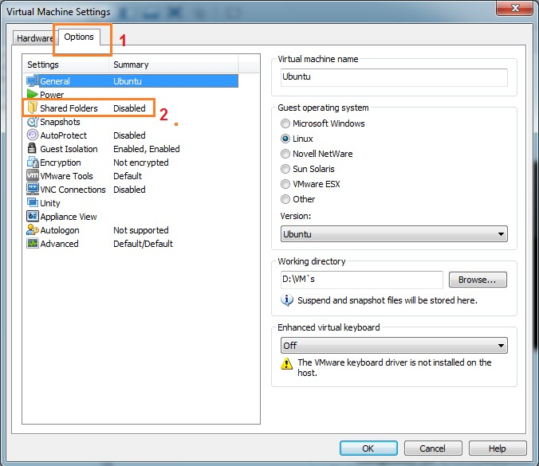

**Viewing Shared Folders in a Linux Guest**

In a Linux virtual machine, shared folders appear under

/mnt/hgfs.

**Note:** Administrative privileges are required. So it might not work on Lab's systems.

**File Editor**

# Date Command:

|  |  |
| --- | --- |
| **Command** | **Description** |
| **date** | The date command displays the current date and time on the screen. The system administrator sets the date users cannot change them. |

**Example:**



There are number of options in which date can be displayed. If you want to see only date, you can do it like this:

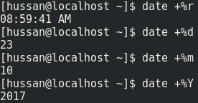

## Clear Command:

|  |  |
| --- | --- |
| **Command** | **Description** |
| **clear** | Clears the screen. |

1. **echo Command:**

|  |  |
| --- | --- |
| **Command** | **Description** |
| **echo** | Echoes back(print) whatever you type on the command line. |

## Who Command:

|  |  |
| --- | --- |
| **Command** | **Description** |
| **who** | Who command lists the login names, terminal lines, and login times of the users who are currently logged on to the |

**Example:**



## Whoami Command:

|  |  |
| --- | --- |
| **Command** | **Description** |
| **whoami** | If you type **whoami**, Linux displays the current logged-in user’s name. |

## System/Kernel Properties:

Linux Kernel comes with complete versioning number with fixed format as given below

### <major>.<minor>.<patch>-<build>.<linux>.<architecture>

Kernel modules are located in **/lib/modules/<kernel version>**

## Exercise:

Print (ls) contents of **/lib/modules** directory by pressing command

### ls /lib/modules

Now run following command

### uname -r

Note output of both above commands.

## Uname Command:

|  |  |
| --- | --- |
| **Command** | **Description** |
| **uname** | Print Operating System Name like **Linux** or **Unix** |
| **Options** | You can use following option with **uname** command  -n print the network node hostname  -r print the kernel release  -v print the kernel version  -m print the machine hardware name  -p print the processor type or "unknown"  -i print the hardware platform or "unknown"  -o print the operating system  -a print complete information of operating system |

# File Sorting:

## Sort Command:

|  |  |
| --- | --- |
| **Command** | **Description** |
| **sort** | Sorts a column in a file in alphabetical order. By default the output is displayed on your terminal, but you can specify filename as the argument or redirect the output to a file. |
| **options** | You can use following option with **sort** command  -r Sorts in reverse order  -b Ignores leading blanks  -f Ignores the distinction between lowercase and uppercase  -k Sorts the output by column  -n Numbers are sorted by their arithmetic values |

**Class Tasks**

1. Run all switches with **uname** command.

-r, -m, -p, -I, -o, -a, -v, -n

And define in one line about these commands according to your understanding.

1. Create new file named **labSort** and insert following text

End of file

6 apples

file to be sorted

apple on the table

23 years old

File To be Sorted

78 apples

Class

3 bananas

99 sort files

Use other option with sort command and observe output.

1. Create another file with name **SortLabNumeric** two columns in it.

12 Online classes

6 Network security

14 Hacking stories

7 Tom and jerry

13 People of Pakistan

One column contains numeric values while other contain text. Now perform sorting on both columns. Also perform **-n** switch on both columns again and observe the pattern.